CUSTOMER LABEL DESIGN
Please fill out the below table with as much detail as possible. For external files please fill in box with “attached – ‘file name’”.
BRAND NAME
IMAGE OF EXAMPLE LABEL / DESIGN YOU LIKE  (can be non-sunscreen related i.e. Makeup, skincare etc.) |  | *insert images, pinterest board link or refer to attached examples*
LOGO |  | *please attach high resolution png (at least 300dpi) with transparent background or .ai file as a separate attachment*
PRODUCT NAME (Must contain “sunscreen”) + SIZE (110,70 or 36)
BACKGROUND COLOUR  (please include HEX# if possible - try: Create a Palette - Coolors, Hex Color picker - Color Picker (colors-picker.com) or images of colours) |  | *max 4 colours (this includes green in Australian Made or VegeCert – black versions can be provided if needed)
FONT COLOUR:
FONT STYLE (round, square, cursive, serif, sans serif etc.)
(Browse Fonts - Google Fonts, Adobe Fonts | Explore unlimited fonts)
KEYWORDS/INFORMATION YOU WOULD LIKE TO APPEAR ON FRONT OF LABEL (i.e. “Vegan”, “Organic”, “Cruelty Free” “For Sensitive Skin”)
KEYWORDS/INFORMATION YOU WOULD LIKE TO APPEAR ON BACK OF LABEL: |  | *optional*
Badges  (Please tick badges you would like + whether you would like them on the fron or back) |  | ☐ Reef Safe  ☐ Cruelty Free  ☐ 100% Organic (NSF)  ☐ Vegecert (Certified Vegan)  ☐ Dermatologically Tested  ☐ Fragrance Free  ☐ UVA UVB UVC Blue Light  ☐ Australian Made Logo  ☐ Anti-Pollution  ☐ Tinted  ☐ OTHER__________ (Please Attach to Email)  ☐ OTHER__________ (Please Attach to Email)
Front and back – split in half or  Front and 2 backs – split in 3 | 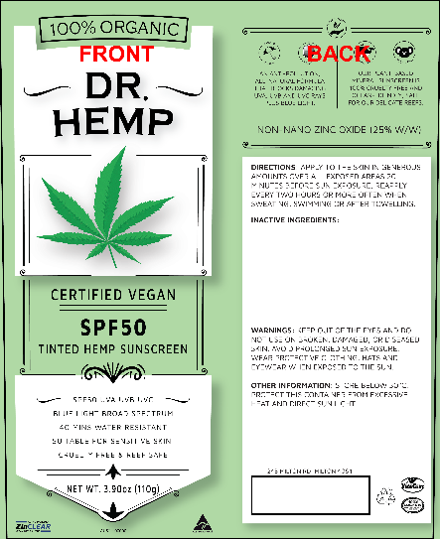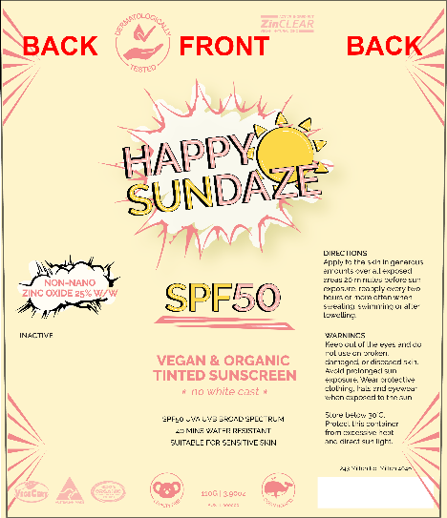
GOLD FOIL: |  | ☐ YES *foil number*  ☐ NO
COMPANY NAME YOU WOULD LIKE TO APPEAR ON BACK OF LABEL:
ADDRESS YOU WOULD LIKE TO APPEAR ON BACK OF LABEL:

CUSTOMER NAME: __________________________________
CUSTOMER SIGNATURE: _______________________________
DATE: ____________________________________________

